A Summary of Papers on Elicitation Individual Preferences

Gonzalo Sanchez
October, 22 2013

Abdellaoui et al (2008)
In this paper the authors propose an efficient method to measure utility under prospect theory. The method is efficient because minimizes the number of elicitations needed and the cognitive burden to subjects. Specifically, the elicitation method uses certainty equivalents for two-outcome prospects to measure utility.
The paper is motivated by pointing out that previous methods did not take into account two of the main violations of expected utility that prospect theory models: probability weighting and loss aversion. As a solution to this problem, Abdellaoui et al (2007) use a non parametric method that does not imposed any assumptions on utility functions, probability weighting or loss aversion. However, the non parametric method is generally sensible to response error and less efficient in the sense that more questions are needed.
In that context, the paper contributes to the literature by developing a method that accounts for response errors while using only 10-12 elicitations and parametric assumptions widely supported in the literature (power utility function). The key point of this method is that only the decision weight of one probability needs to be known to measure utility. Hence, the method does not require assumptions about probability weighting.
The elicitation method consists of three stages. Elicitation of utility on the gain domain, elicitation of utility on the loss domain, and in the third stage, the utility on the gain and loss domains are linked to estimate loss aversion.
The elicitation of certainty equivalents uses a bisection process (Table 10 in the paper). The chosen prospects are printed in bold in the table. The starting values have the same expected value. Depending on the choice made, the certain outcome was decreased or increased (the change was half of the size of the change in the previous question). The indifference value was the midpoint of the two last iterations.

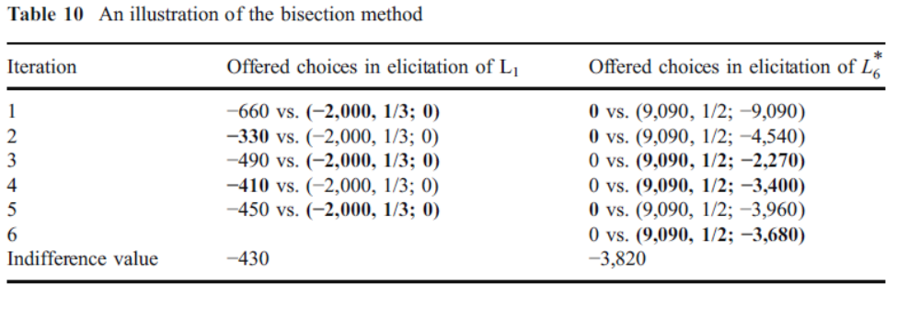
The estimations in this model are implemented by using non linear least squares. In particular the estimates are α, the coefficient of the curvature of the power utility function, and the probability weighting.
The main findings of the paper are that the results confirm most previous findings on prospect theory. In particular, the results indicate that most subjects are risk averse for gains and risk seeking for losses, and that there is strong evidence of loss aversion. Also, a novel result is that concave utility and risk seeking behavior for losses may coincide.
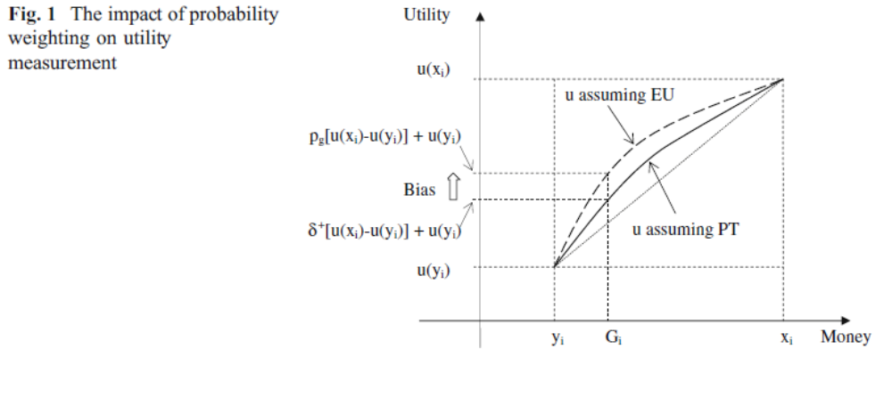
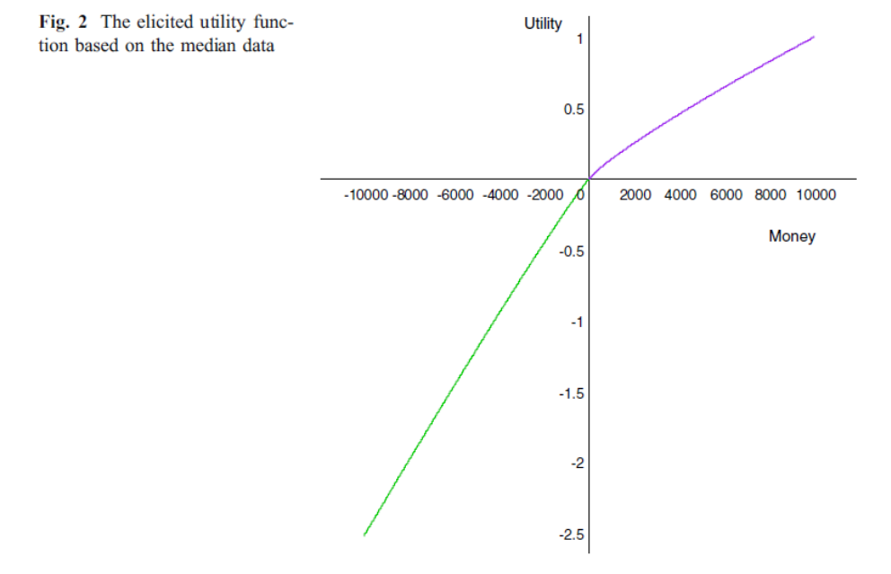
Bellemare and Shearer (2010)
This is a field experiment to measure risk preferences of workers that face substantial income risk. The paper is motivated by pointing out the importance of risk and risk preferences in studying labor contracts. Previous research had failed to detect the role of risk in contract choices. The main problem in this context is the presence of unobserved risk preferences. If workers sort themselves into activities on the basis of their risk preferences, then regression methods will confound changes in risk with changes in unobserved risk preferences. The paper studies empirically the sorting hypothesis, by using the elicitation method proposed by Holt and Laury (2002), to identify risk preferences of employees that face substantial income risk. The paper also compares these results with risk preferences form a broader population.
The experiment was conducted within a medium sized tree-planting firm in Canada. The daily earning of planters are determined by the product of the piece rate (determined by the firm) and the number of trees planted per day. Planting conditions vary across and within blocks. Then some planters will end up working in more difficult conditions, under the same contract.
The experiment uses the method proposed by Holt and Laury (2002) using a low stakes treatment and a high stakes treatment (payoff twice as much the low stakes). Table 1 in the paper shows the payoffs. Using a CRRA utility function the authors classify subjects into risk categories (Table 2).
The results indicate that approximately 40% of the planters are either risk loving or risk neutral. This proportion is significantly higher than in the broader population (around 17%). The findings suggest that sorting over risk preferences is an important characteristic of labor-market contracts.

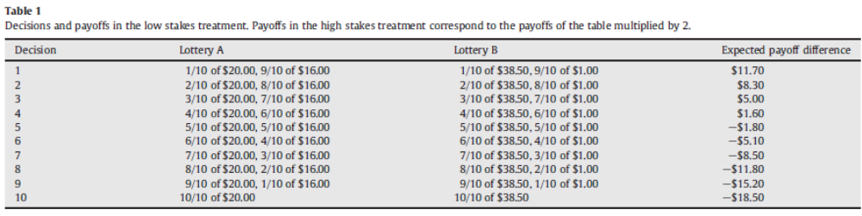
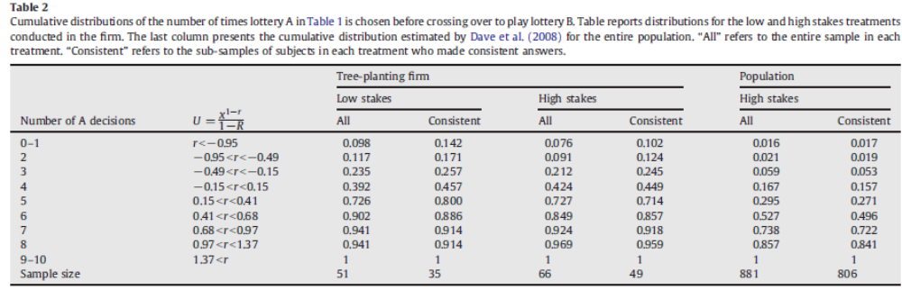
Crosetto and Filippin (2013)
This is a working paper that carries out a comparative analysis of incentivized tasks to elicit risk preferences. The comparison is performed both theoretically and empirically. The paper is motivated by drawing attention to the lack of robustness of experimental methods used to measured risk attitudes. In particular, there is low correlation between the behavior in different tasks. In the paper is pointed out that this empirical peculiarity may be driven by a within-subject comparison, since this procedure is likely to induce subjects to form a hedging across periods. In that context the authors use a between-subject design instead, with a homogeneous pool of subjects.
The paper compares five risk elicitation tasks
- Multiple price list (Holt and Laury, 2002) (HL)
Ordered list of binary choices between lotteries as follows, in which the probabilities are changed while the outcome are the same across choices.
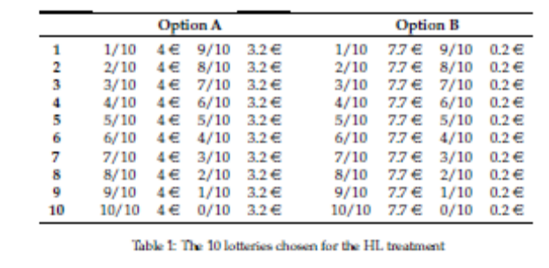

- Ordered lottery choice (Eckel and Grossman, 2002, 2008) (EG)
Subjects choose the lottery preferred within a set of 5 lotteries characterized by a linearly increasing expected value as well as greater standard deviation. (Manipulation in outcomes, same probabilities)
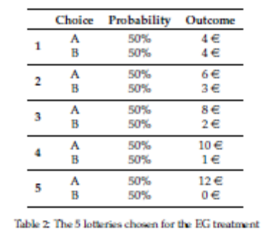
- Investment Game (Gneezy and Potters, 1997 and Charness and Gneezy) (CGP)
The choice is framed as an investment decision. Subjects decide how to allocate an endowment of 4 euro between a safe account and a risky lottery, that with 50% probability, yields 2.5% the amount invested, and zero otherwise, thereby generating a set of lotteries:
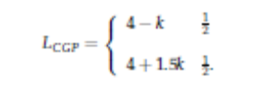
- Ballon Risk Task (Lejuez et al, 2002) (Ballon)
This task is characterized by a balloon which has an explosion point. Subjects earn 0.1 euro each time they pump the balloon, in the case it explodes, the earnings are set to zero.

- Momb Risk Elicitation Task (Crosetto and Filippin, 2013b)
This is a visual real-time elicitation task. Subjects face a 10x10 square in which each cell represents a box. There are 100 boxes an only one contains a bomb, which is programmed to explode at the end of the task. One box is collected and the subject’s provisional account is credited with additional 20 euro cents each second. The subject can at any time stop the process, and determine the preferred number of boxes to be collected (k). The position of the bomb is determined after choices are made by drawing a number from 1 to 100 (b). If b≥k, the subject collected the bomb, and gets zero earnings. If b<k the subject receives 20 euro cents for each bomb collected.
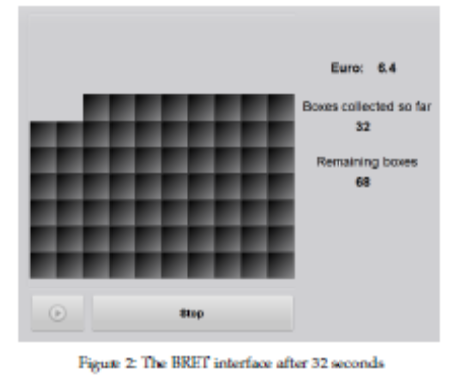
Two self-reported questionnaire measures are included:
- German Socio-Economic Panel Study risk question (Wagner et al, 2007) (SOEP)
- Domain-Specific Risk-Taking Scale (Blais and Weber, 2006 (DOSPERT)
The project included 144 subjects in 16 experimental sections. Each subject took part on only one risk elicitation task, and after that the two questionnaires were completed. Each choice in each task was translated into parameters of a CRRA utility function (Table 4). Among the tasks that do not suffer from loss aversion, there is higher risk aversion in HL (0.32) than in the BRET (0.66). There is a notable correlation between the likelihood of observing gender differences in risk attitudes and the importance of loss aversion.
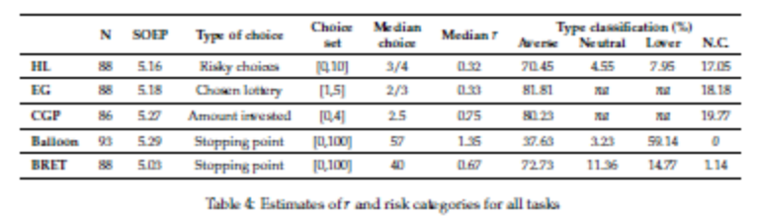
The Parametric maximum likelihood estimation shows that risk aversion is stronger in HL and EC once gender differences are considered in the latter.
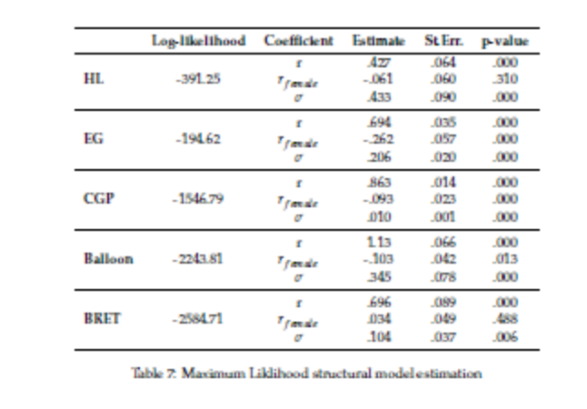
Finally, with few exceptions, choices in the task are orthogonal to the answers provided in the questionnaires.

References

Abdellaoui, Mohammed, Han Bleichrodt, and Corina Paraschiv. (2007). “Measuring Loss Aversion under Prospect Theory: A Parameter-Free Approach,” Management Science 53, 1659–1674.

Abdellaoui, Mohammed, Han Bleichrodt, and Olivier l’Haridon. (2008)"A tractable method to measure utility and loss aversion under prospect theory." Journal of Risk and Uncertainty 36.3: 245-266.

Bellemare, C., & Shearer, B. (2010). Sorting, incentives and risk preferences: Evidence from a field experiment. Economics Letters, 108(3), 345-348.

Blais, A.-R. and Weber, E. U. (2006). A Domain-Specific Risk-Taking (DOSPERT) scale for adult populations. Judgment and Decision Making, 1:33–47.

Charness, G. and Gneezy, U. (2010). Portfolio Choice And Risk Attitudes: An Experiment. Economic Inquiry, 48(1):133–146.

Crosetto, P. and Filippin, A. (2013b). The ’bomb’ risk elicitation task. Journal of Risk and Uncertainty, Forthcoming.

Crosetto, P., & Filippin, A. (2013). A theoretical and experimental appraisal of five risk elicitation methods.
Eckel, C. C. and Grossman, P. J. (2002). Sex differences and statistical stereotyping in attitudes toward financial risk. Evolution and Human Behavior, 23(4):281–295.

Eckel, C. C. and Grossman, P. J. (2008a). Forecasting risk attitudes: An experimental study using actual and forecast gamble choices. Journal of Economic Behavior & Organization, 68(1):1–17.

Gneezy, U. and Potters, J. (1997). An Experiment on Risk Taking and Evaluation Periods. The Quarterly Journal of Economics, 112(2):631–45.

Holt, C. and Laury, S. (2002). Risk aversion and incentive effects. American Economic Review, 92(5):1644–1655.

Lejuez, C., Read, J., Kahler, C., Richards, J., Ramsey, S., Stuart, G., Strong, D., and Brown, R. (2002). Evaluation of a behavioral measure of risk taking: The Balloon Analogue Risk Task (BART). Journal of Experimental Psychology: Applied, 8(2):75.

Wagner, G. G., Frick, J. R., and Schupp, J. (2007). The german socio-economic panel study (soep): Scope, evolution and enhancements. SOEPpapers on Multidisciplinary Panel Data Research 1, DIW Berlin, The German Socio-Economic Panel (SOEP).

